CHORAL-AIRES CHORUS
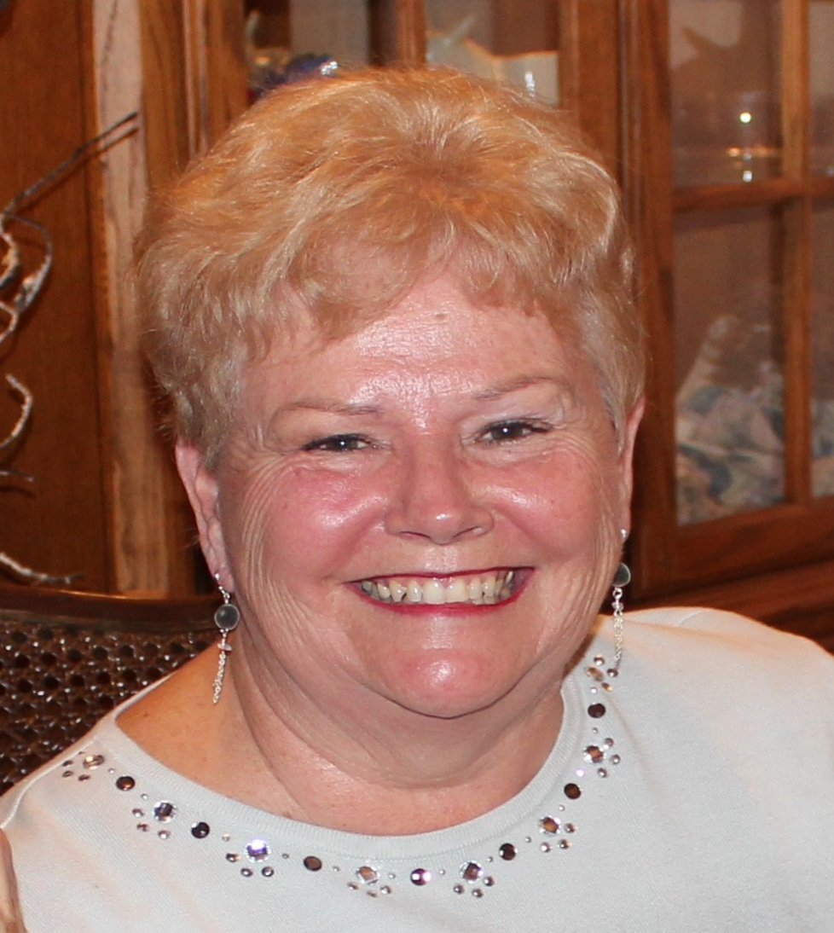
Bev Hoffmeister
Bev joined Choral-Aires on November 6, 1999. In her 17 years as a member she has served the chorus in so many ways. She has been a member of the BOD and is our immediate past president. Fashion Show, Regional Competition, International Competition, and fund raising are just a few of her areas of expertise. Bev also sings in A La Carte, a small daytime group of performing Choral-Aires. She has been married to Don for 48 years, and they have 2 sons and 1 granddaughter. When Bev takes on a project, she gives it her all. She and Don promote Sweet Adeline’s wherever they go and they have gotten hundreds of dollars of donations for our chorus. She is one of our most dedicated members and she is Sweet Adelines.

