GREAT LAKE SOUND CHORUS
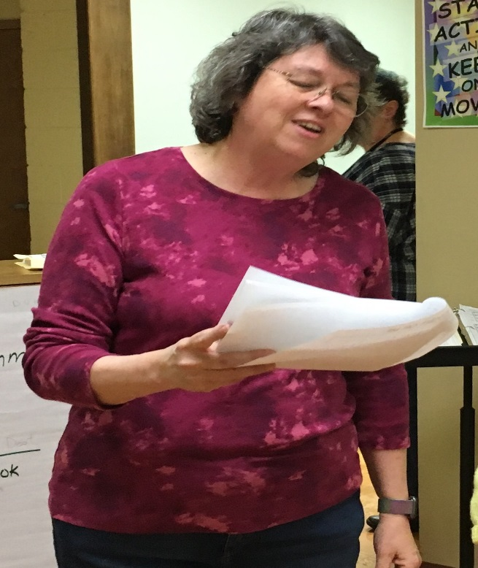
Lee Riley
Her willingness to help out (without any nudging) is something to be admired. In a small chorus it is often difficult to get people capable and willing to take on the tasks that Lee not only handles with grace but appears to enjoy it because she always has a smile on her face. She supports the Management team by applying her abilities in various “technical” areas. Keeping music updated with changes and supply us “clean copies” are just a few of the things she does to support the musical team. She was also key to setting up our new website using Groupanizer.
So much of her work is done behind the scenes, but that doesn’t mean she isn’t there to assist in more personal ways by supporting her baritone section when the section leader is not available (and in any other capacity as needed).
This is one lady that any chorus would be proud to call their member. I know we are!

