WESTOSHA LAKES CHORUS
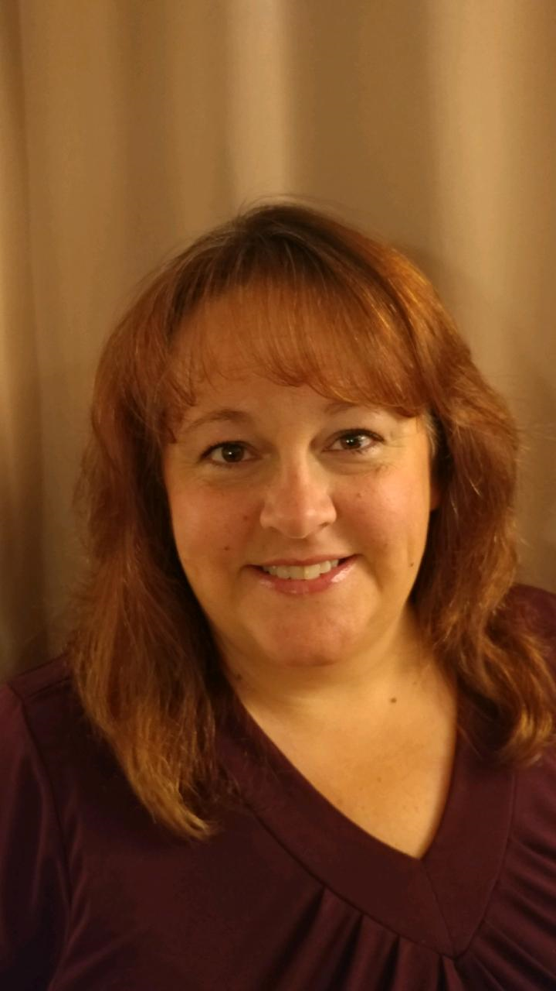
Barb Porteous

…Barb joined Sweet Adelines in 2014. She has been a welcome addition to our Tenor section. Alone with her singing experience and smile she has served on our Leadership committee as the Fundraiser chairperson. She coordinated our first annual golf outing that was fun, entertaining and profitable. Barb continues to work hard on her music and personal relationships with all the members of Westosha Lakes Chorus to help bring the chorus harmony together.

