RIVER BEND CHORUS
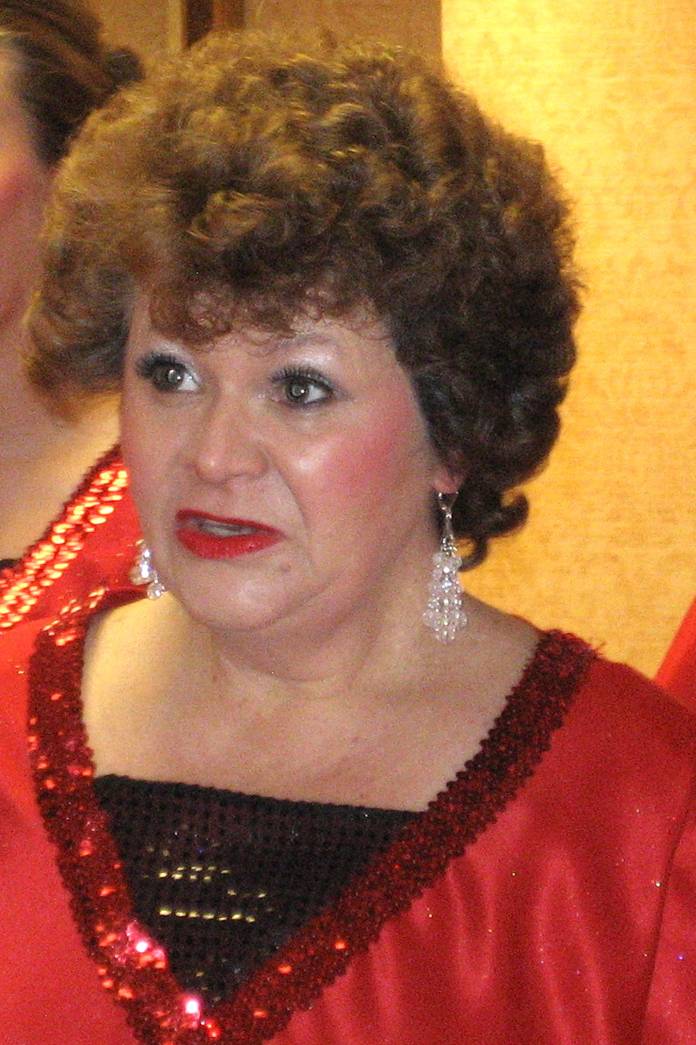
Debbie Strasser
Debbie joined River Bend Chorus, South Bend, IN in February, 1999. She has sung Lead, Bass and Baritone in the chorus, so you can tell she's versatile and dedicated! Debbie has served as a leader of the chorus in multiple roles: Secretary, Membership (more than once) and Team manager (also more than once) also librarian, rookie coordinator, and choreographer. (Showmanship).
In 2016 she filled in for our Membership Coordinator when she had to take a medical LOA.

Debbie and her husband, Jack, have raised their own children and are currently foster parenting children for whom they provide a stable home environment and love every day.

