RIVERPORT CHORUS
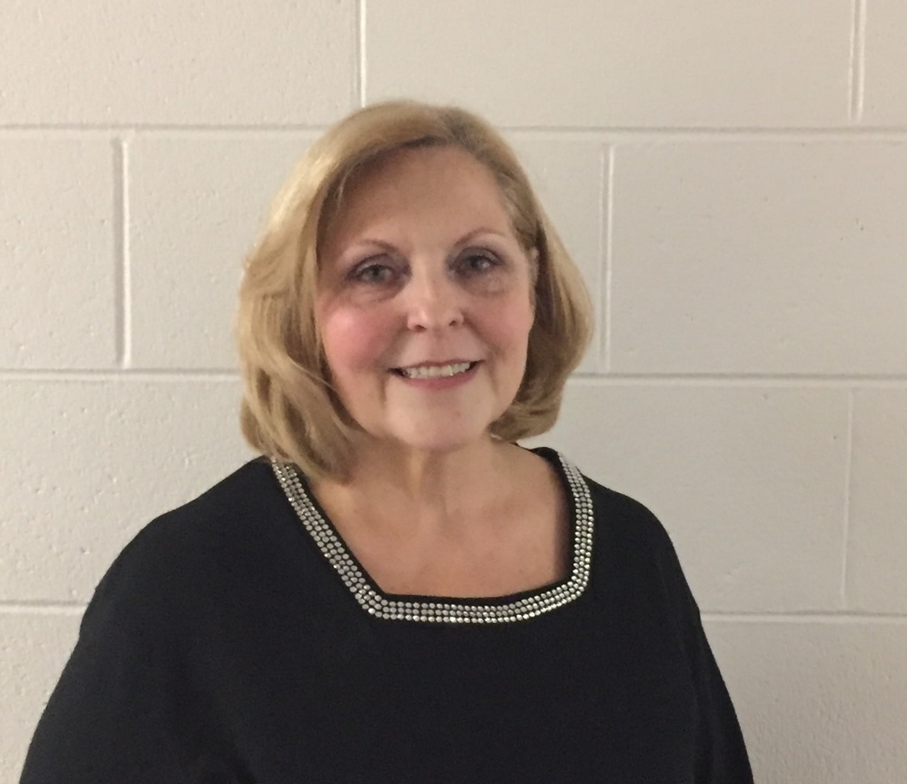
Dona Grebe
Dona has been an active member, week in and week out, year after year for 35 years. This positive woman is always looking for ways to help other members enjoy our barbershop craft.
As well as serving on our management team, Dona chairs our annual craft fair and has been instrumental in making it successful. She also is in charge of our chorus social committee and no party escapes her special touch.
Dona is a gracious lady who wears a smile and has a friendly greeting for all. Riverport appreciates her helpful touch to all of our activities and we are proud to name Dona as our “Woman of Note” 2017.

