SPIRIT OF THE LAKES CHORUS
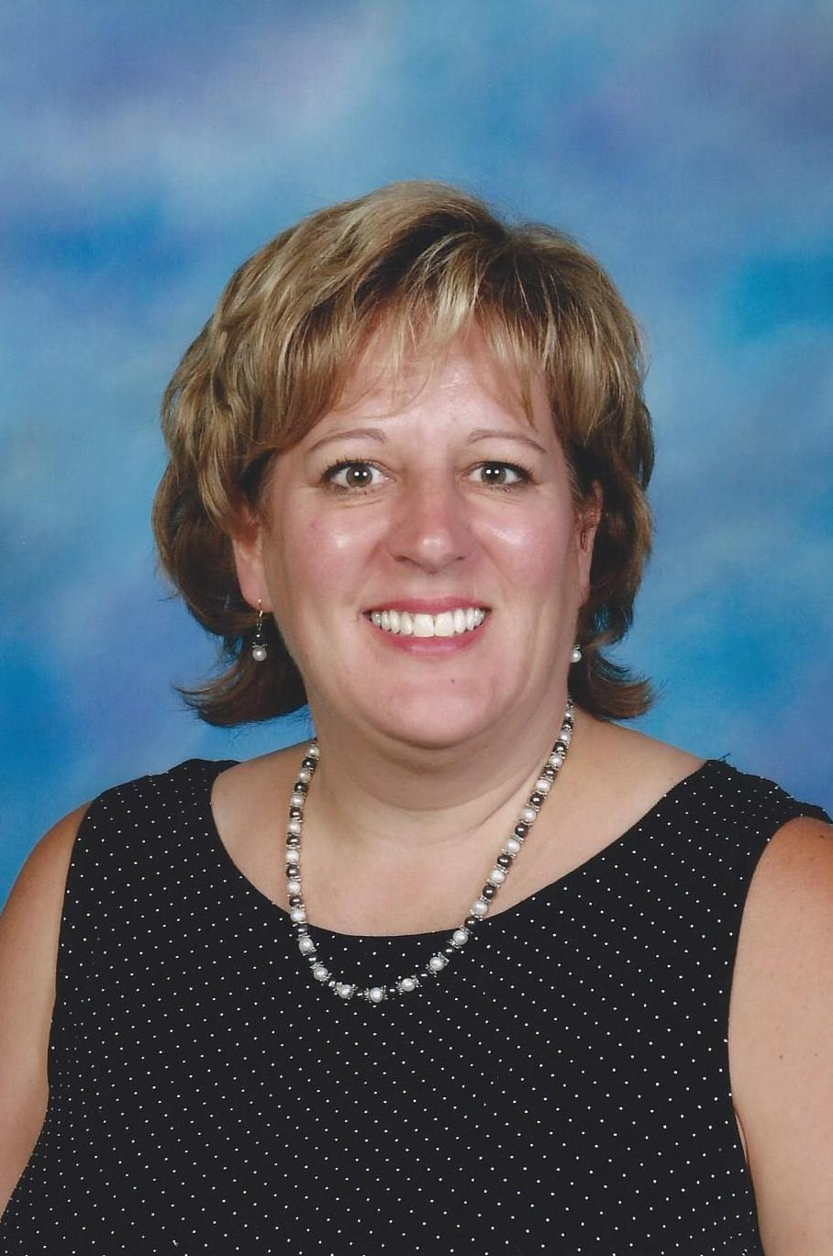
Roberta Zess
Roberta joined the Spirit of the Lakes Chorus in the fall of 2007. She talks about her first meeting with the women of the chorus. “I met the Spirit of the Lakes ladies at the county fair in the County’s tourism booth. I’ll never forget how cheery they were, and how I felt that they were instant friends. I attended their show that October and became hooked. After 9 years, I am still excited to come to chorus and try to spread the ‘fun and friendships’ to all that attend.”
Roberta’s shining personality and friendly nature make her a standout in Spirit of the Lakes Chorus. In addition to being a great baritone, she is an enthusiastic member who has given so many of her talents to the group. For 6 years, she was the Marketing Liaison for the chorus. Roberta always came up with eye-catching advertisements and creative fliers. She developed a new chorus brochure, provided backdrops for the Cabarets, designed a CD cover, set up a “Sing for your Health” booth at a local women’s fair and recently coordinated a food booth chorus fundraiser. Roberta continues to play an important role in technology for the chorus; she sets up projectors, tapes coaching sessions and keeps chorus information updated on Facebook. She is currently a member of the costume committee, and because of her enjoyment for photography, takes pictures of the memorable events of the chorus. Roberta is a woman of many roles. This was again exemplified in June, when the Financial Coordinator position for the chorus became vacant and Roberta stepped up and took over the job. Roberta is, without question, this year’s “stand-out member” of the chorus. With love in our hearts, the Spirit of the Lakes is very happy and proud to select Roberta Zess as our “Woman of Note” for 2017. Congratulations, Roberta!

