VERMILLION VALLEY SHOW CHORUS
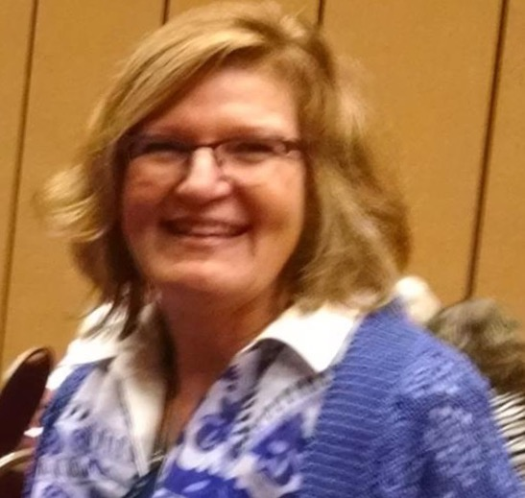
Rhonda Hornstein
... She does Physical and Vocal warm ups for our Chorus and is ready to jump in whenever needed. She serves on the Music Committee. She sings Lead and Tenor and is willing to sing whichever part she is needed on. She is our Show Chairman and with ease (or so it appears), locates wonderful venues, arranges for dates and keeps everyone updated on the needs for the Show. She remains cheerful and smiling throughout even when 30 other women feel she needs their input. We are so fortunate to have her be a part of our Chorus.

